**Tasks given in manual**

**Task 01)**

|  |  |  |  |  |  |  |  |  |  |  |
| --- | --- | --- | --- | --- | --- | --- | --- | --- | --- | --- |
| **Inputs** | | | | | | | | **Outputs** | | |
| **D0** | **D1** | **D2** | **D3** | **D4** | **D5** | **D6** | **D7** | **A1** | **A2** | **A0** |
| X | X | X | X | X | X | X | L | 0 | 0 | 0 |
| X | X | X | X | X | X | L | H | 0 | 0 | 1 |
| X | X | X | X | X | L | H | H | 0 | 1 | 0 |
| X | X | X | X | L | H | H | H | 0 | 1 | 1 |
| X | X | X | L | H | H | H | H | 1 | 0 | 0 |
| X | X | L | H | H | H | H | H | 1 | 0 | 1 |
| X | L | H | H | H | H | H | H | 1 | 1 | 0 |
| L | H | H | H | H | H | H | H | 1 | 1 | 1 |

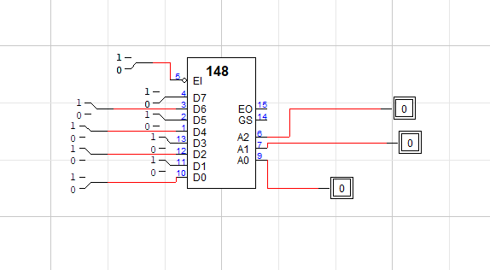

**Task 02)**

|  |  |  |  |  |  |  |  |  |  |  |  |  |
| --- | --- | --- | --- | --- | --- | --- | --- | --- | --- | --- | --- | --- |
| **Decimal Inputs** | | | | | | | | | **Outputs** | | | |
| **D0** | **D1** | **D2** | **D3** | **D4** | **D5** | **D6** | **D7** | **D8** | **A3’** | **A2’** | **A1’** | **A0’** |
| X | X | X | X | X | X | X | X | L | 1 | 0 | 0 | 1 |
| X | X | X | X | X | X | X | L | H | 1 | 0 | 0 | 0 |
| X | X | X | X | X | X | L | H | H | 0 | 1 | 1 | 1 |
| X | X | X | X | X | L | H | H | H | 0 | 1 | 1 | 0 |
| X | X | X | X | L | H | H | H | H | 0 | 1 | 0 | 1 |
| X | X | X | L | H | H | H | H | H | 0 | 1 | 0 | 0 |
| X | X | L | H | H | H | H | H | H | 0 | 0 | 1 | 1 |
| X | L | H | H | H | H | H | H | H | 0 | 0 | 1 | 0 |
| L | H | H | H | H | H | H | H | H | 0 | 0 | 0 | 1 |
| H | H | H | H | H | H | H | H | H | 0 | 0 | 0 | 0 |

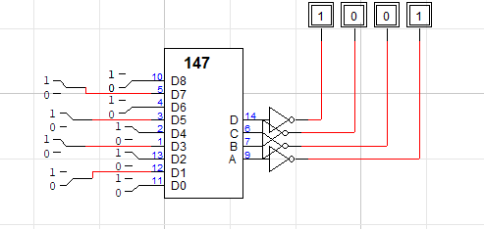

**Tasks not mentioned in manual**

**Task 03**

**Fig 4(Implementation of 74_148 IC with 7 segment display)**

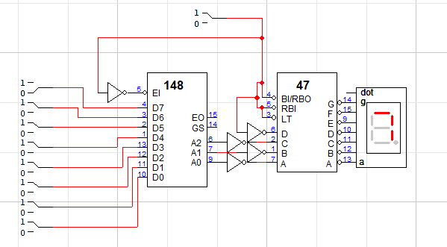

**Task 04**

**Implementation of 74_147 IC with 7 segment display**

